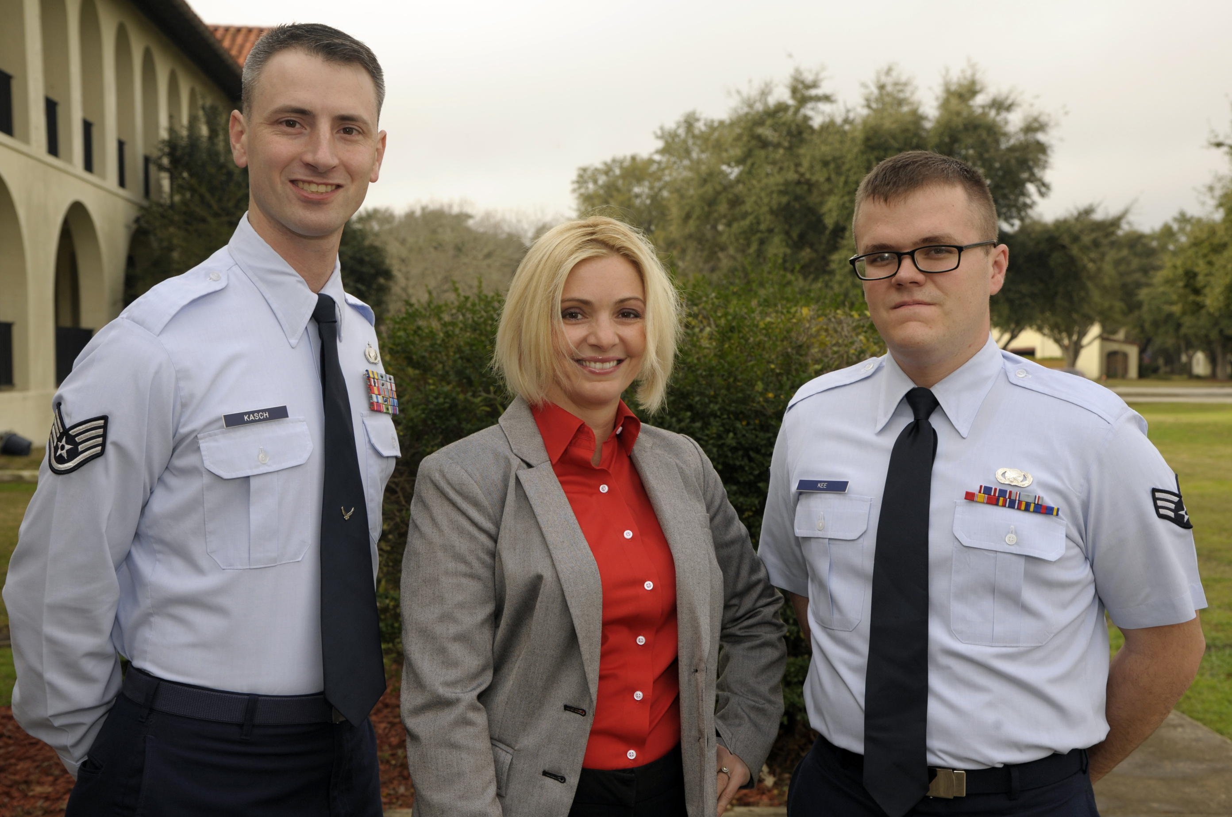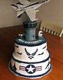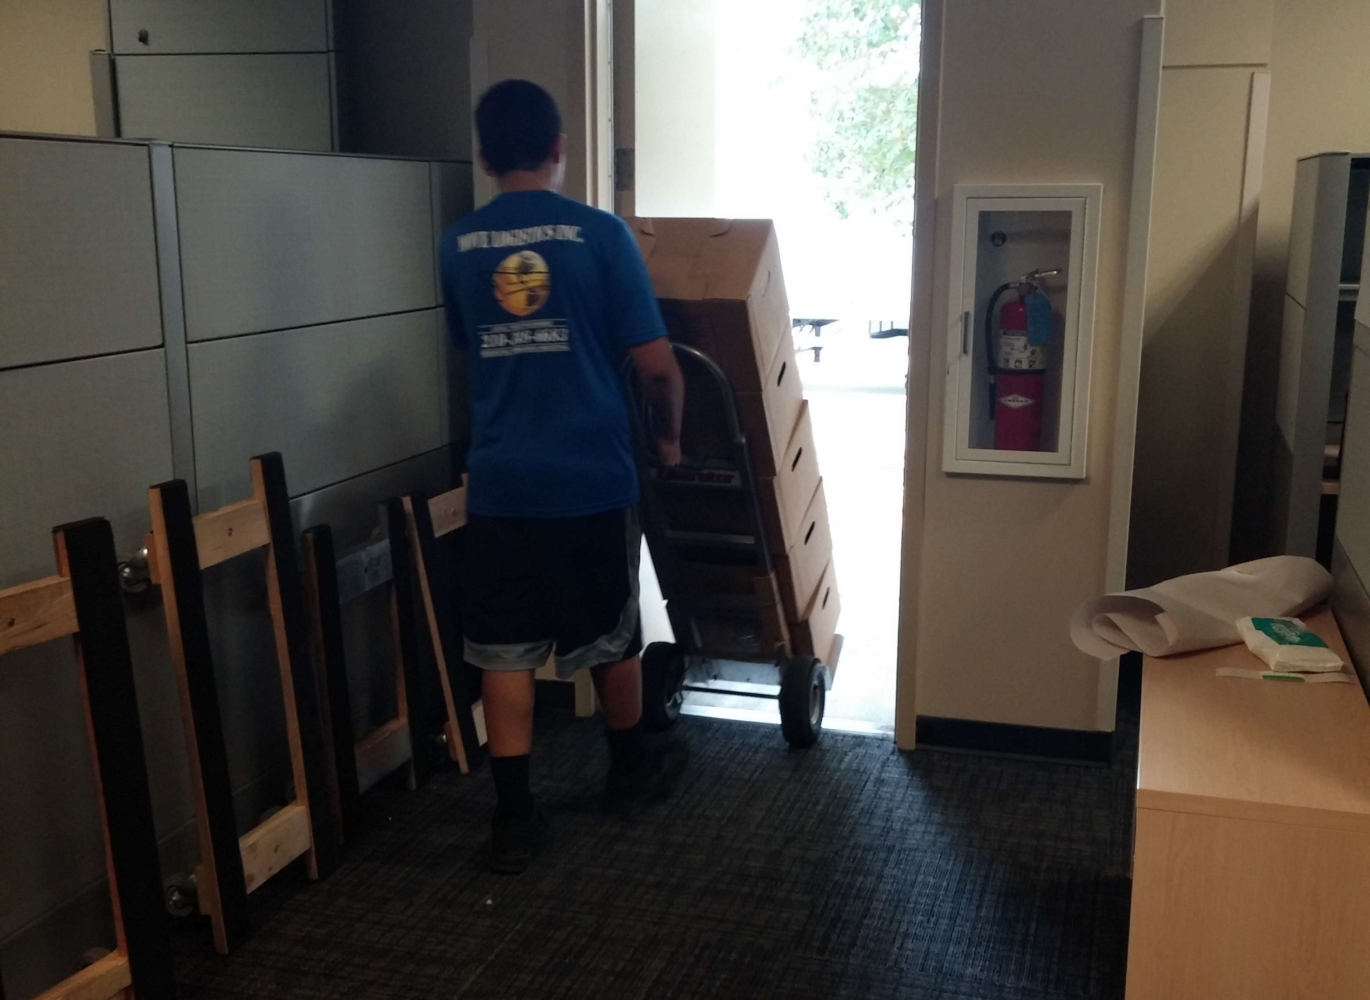

The Air Force will celebrate its 70th anniversary in 2017! Want a piece of the cake? We recommend you start brainstorming your commemorative concepts now and submit them through the [Trademarx Online approvals site](http://usaf.trademarxonline.com) as soon as possible.

Trademarx Online will be adding a new sales reporting feature this year that will maximize efficiency for submitting sales reports. The new feature will allow licensees to upload their data in their own format and map their data to the terms in [Trademarx Online license management site](http://licensing.trademarxonline.com).

Watch your email for more details.

PLAN continued on Page 4

More payment options are coming your way later this year. We are currently in discussions with the Treasury Department regarding their receivables program. The program will allow greater flexibility in your payment options, including the use of credit cards, PayPal, and Pay.Gov.

We will provide more information to you via email and *TM Connect* as we get closer to launching.

#### On the Horizon

### Issue 1, 1Q/16

## New Year – New Business Plan

Each year licensees are required to submit their business plan for the upcoming year. The business plan allows you to critically evaluate the success of our Brand for your company and plan the way ahead to increase sales for the next four quarters.

Do you see new opportunities and want us to consider expanding the scope of your license? Is there a new product you’d like to introduce? Maybe there’s a new distribution channel you’d like to enter. This is your chance to make those requests and provide supporting data for the expansion.

The business plan is also your opportunity to review your previous year’s activity, report on your advertising expenses for your licensed merchandise, confirm you met the annual minimum sales and royalty requirements, submit your annual factory compliance inspections, and tell us what we can do to help you.

On our homepage we have uploaded an outline for your business plan and a worksheet to list your distribution channels. Please include the worksheet with the business plan.

We have extended the Jan. 30 deadline. Plans should be emailed to our office no later than Feb. 29, 2016.

TM connect

Welcome to the first issue of *TM Connect*. We trust our newsletter will help keep you up-to-date on future events, new requirements, and upgrades to the Air Force Branding & Trademark Licensing Program. We are excited about the licensing potential out there and look forward to working with you to increase sell through in the New Year. - April, Brad, Zach

# Welcome 2016

##### Air Force Branding & Trademark Licensing

Photo by SrA Zachary Kee

Courtesy photo

## **License Compliance:** It’s everybody’s job

In the past four quarters, there has been nearly $19M in reported sales of officially licensed Air Force-branded merchandise. Computer accessories account for $4.6M of those sales.

The addition of the Trademarx Online license management tool to our office in 2014 has given us a clearer picture of where Air Force-branded merchandise is being sold.

It also shows us when licensees are operating outside their authorized items, distribution channels, territories, and manufacturers.

Review the table of exhibits in your license agreement. If you find you’ve inadvertently exceeded the scope of your agreement, notify us so we can work toward a solution.

Failure to comply with the terms of your license could effect a renewal decision.

Air Force Branding & Trademark Licensing

Air Force Public Affairs Agency

555 E Street East, Suite 3, Room 113

JBSA-Randolph, TX 78150

Have you been trying to reach us and no one is responding? You could have outdated information in your contacts.

All email correspondence should be sent to [licensing@us.af.mil](mailto:licensing@us.af.mil) and/or [afpaa.hq.tl@us.af.mil](mailto:afpaa.hq.tl@us.af.mil). If you’re emailing an individual, there’s a high probability that Airman has moved to a new duty assignment, is deployed, has been placed on a special project with another office, or has separated from the Service.

Please remove any personal email addresses from your contacts and replace it with our organizational email address.

Additionally, most of you are aware that our offices moved across town last fall. If you are still sending payments, insurance certificates, or product samples to our former address, they are not being forwarded to the new office site.

Our address and phone number can be found on our website: [www.trademark.af.mil](http://www.trademark.af.mil)

Please socialize this address with your insurance company so they can update the Certificate of Insurance. Also, confirm with your accounting office that the check printer has been updated with our new address.

## **Staying Connected:** Correct contact info vital for data sharing

*Unidentified bodies from factory rubble lie on the ground as people gather for a mass burial in Dhaka, Bangladesh on May 1.*

Photo courtesy of CNN.com

# **Social Responsibility:** Inspect your factories to ensure human rights are protected

Price points matter. However, it’s important to remember that we can’t put a dollar figure on human life and human dignity. Unfortunately, sourcing decisions are sometimes made with an eye on competitive pricing, not the human cost.

Luckily, the U.S. Department of Labor’s Bureau of International Labor Affairs (ILBA), in response to the Trafficking Victims Protection Reauthorization Act of 2005, provides a tool that helps companies be more socially responsible when sourcing from overseas locations.

The ILBA continuously monitors international industries and maintains a list of goods produced by child labor and/or forced labor on the [Labor Department’s website](http://www.dol.gov/ilab/reports/child-labor/list-of-goods/). This list is a living document; the website is updated as needed.

It is the Air Force’s position that Air Force-branded merchandise generally should not include goods from the industries in regions listed on the ILBA.

For clarity, Hong Kong and Taiwan are NOT included in the “China” entry.

Licensees should thoroughly review the source of the goods comprising licensed Air Force merchandise (including the blanks), from the thread used in the hemline of a t-shirt to the zippers in bags, and cross-reference the goods with ILBA’s list.

If you find your licensed product includes goods on the list, contact us so we can discuss the way ahead. All new licenses and renewals must be in compliance with the Air Force position prior to finalizing the license. Plan now.

A new verification tool is now available for download that can boost consumers’ confidence that they are buying officially licensed merchandise when they shop online, and simultaneously boost your authenticity as an official Air Force licensee.

JPatton has created the Online Merchant Seal (OMS) that can be displayed on the licensed product’s webpage.

The intent is to have the OMS appear on the product’s “add to cart” page on as many of the online retail outlets as possible.

Details on how to obtain the code for the OMS can be found under “Resources” when you log into your [JPatton](https://jpattonondemand.com/) account.

Once on the JPatton home page, click the “sign in” link at the top of the page. On the next page, click the Air Force icon.

If you do not have a username and password, notify us via email. Include your company name, your name and your email address.

All new licenses and renewals will be required to display the OMS as part of their online retail presence (as practical).

PLAN from Page 1

### Tip

If you’ve tried to read a millennial’s text lately, you’ll likely see that the military no longer holds the market on acronyms.

Gone are the days of “lol,” “smh” and “brb.”

One acronym of particular interest to us is the growing use of “AF.” (If you don’t know what that means, ask the nearest 20-something-year-old or check the urban dictionary. But we promise you, it’s not “Air Force.”)

With this in mind, please review your current Air Force line and any concept designs being developed. If “AF” can be interpreted in the “new” way, our office will need to revisit these items.

Do you want to increase your chances of getting your designs and products approved by us the first time around? We will post tips and trends in the Approvals Corner to help you get your product design from concept to store shelves in less time.

**Tip 1:** Read the style guide available in your JPatton account. We are serious about the stand-off space!

**Tip 2:** To get approval, you must upload the item(s) in the Trademarx Online approval site. We can’t approve what’s not submitted.

#### Approvals

#### Corner

#### Trending: Acronyms

# **Online Merchant Seal:** Increase consumer confidence

# **Online Merchant Seal:** Increase consumer confidence

Photo courtesy of www.af.mil

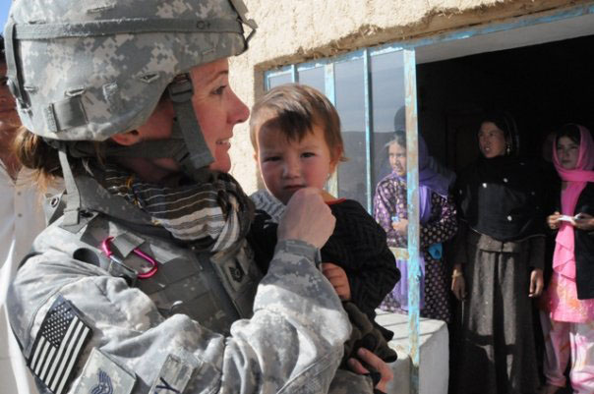

Wanted: Memorial Plaques

Do you offer all-weather, metal memorial plaques? Is that reflected on our website?

Recently the DoD Voluntary Education Office reminded colleges they must have our approval to display our logos in Veterans Centers and on memorials.

Many schools were erroneously using our Seal and are now replacing the Seal with either the Emblem or Symbol. We have directed the schools to use an official licensee for the replacement item(s).

Our goal is to ensure we have your information captured properly on our website when schools search for a supplier.

Please check our website at: www.trademark.af.mil/licenseholders

Licensing is a fascinating, ever evolving field. Because of that we have multiple initiatives working to improve the visibility of our Brand and the way it is represented in the marketplace.

That’s one reason we’re bringing you *TM Connect* – to help keep you on top of what’s happening in the Air Force Branding & Trademark Licensing Office and to keep you informed of upcoming events your sales team may be able to capitalize on.

Any good communication is a two-way street. Let us know what you would like to see from us to help you take advantage of new trends. While we must remain true to our Brand, your feedback and ideas may help us find new ways to reach the next generation of our Nation’s defenders.

Thanks for promoting the world’s premier Air Force. Aim High…Fly! Fight! Win!

-April Rowden, Senior Manager

### Final Thoughts

Photo courtesy ofwww.af.mil

"It's clear to all of us that women are contributing in unprecedented ways to the military's mission of defending the nation… Female service members have faced the reality of combat, proven their willingness to fight and, yes, to die to defend their fellow Americans." – Leon E. Panetta, former Defense Secretary

The Air Force recently announced it will be opening up the six remaining career fields previously closed to women. [http://www.af.mil/](http://www.af.mil/News/ArticleDisplay/tabid/223/Article/109017/air-force-sets-plan-to-integrate-women-in-combat-jobs-by-2016.aspx)

# **Women Matter:** Merchandise needed to honor women warriors

In January 2015, several news agencies reported on the shaming of a female veteran parked in a “veterans only” spot. A stranger left a scathing note on the veteran’s car, wrongfully criticizing her for parking there.

The news reports highlighted an ongoing misconception by the American public: that only men are veterans and warriors.

More than 19% of the Air Force uniformed members are female. (That’s nearly 61,000 daughters, mothers, sisters, and wives proudly serving in the U.S. Air Force.) And more than 2 million of our veterans are women.

We challenge our licensees to help change the public misconception. Develop designs that recognize women warriors and those who back our women warriors – children, spouses, parents, siblings.

We will be highlighting the items on our website as products are approved.